**Nama : Firly Nurlya Rahim**

**NPM : 4510210032**

**Praktikum sesi 3 - Pemrograman 4**

* Membuat folder menggunakan maven

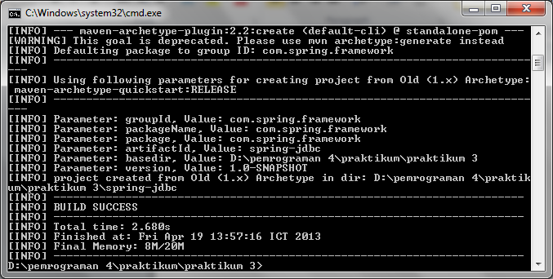

* Pom.xml

<project xmlns="http://maven.apache.org/POM/4.0.0" xmlns:xsi="http://www.w3.org/2001/XMLSchema-instance"

xsi:schemaLocation="http://maven.apache.org/POM/4.0.0 http://maven.apache.org/xsd/maven-4.0.0.xsd">

<modelVersion>4.0.0</modelVersion>

<groupId>com.firly.sesi3</groupId>

<artifactId>aplikasi-web-sederhana</artifactId>

<version>1.0-SNAPSHOT</version>

<packaging>jar</packaging>

<name>aplikasi-web-sederhana</name>

<url>http://maven.apache.org</url>

<properties>

<project.build.sourceEncoding>UTF-8</project.build.sourceEncoding>

</properties>

<dependencies>

<dependency>

<groupId>junit</groupId>

<artifactId>junit</artifactId>

<version>3.8.1</version>

<scope>test</scope>

</dependency>

<dependency>

<groupId>org.springframework</groupId>

<artifactId>spring-jdbc</artifactId>

<version>3.2.2.RELEASE</version>

</dependency>

<dependency>

<groupId>mysql</groupId>

<artifactId>mysql-connector-java</artifactId>

<version>5.1.22</version>

</dependency>

<dependency>

<groupId>commons-dbcp</groupId>

<artifactId>commons-dbcp</artifactId>

<version>1.4</version>

</dependency>

</dependencies>

</project>

* Config-spring.xml

<?xml version="1.0" encoding="UTF-8"?>

<beans xmlns="http://www.springframework.org/schema/beans"

xmlns:xsi="http://www.w3.org/2001/XMLSchema-instance"

xsi:schemaLocation="http://www.springframework.org/schema/beans

http://www.springframework.org/schema/beans/spring-beans.xsd">

<bean id="dataSource" class="org.apache.commons.dbcp.BasicDataSource">

<property name="driverClassName" value="com.mysql.jdbc.Driver"> </property>

<property name="url" value="jdbc:mysql://localhost/<nama-database>"> </property>

<property name="username" value="root"> </property>

<property name="password" value=""></property>

</bean>

* **Produk.java**

package com.firly.sesi3;

import java.math.*;

public class Produk {

private Integer id;

private String nama;

private String kode;

private BigDecimal harga;

private date terakhirUpdate;

public void setNama(String nama){

this.nama=nama;

}

public String getNama() {

return nama;

}

public void setKode(String kode) {

this.kode=kode;

}

public String getKode() {

return kode;

}

public void setHarga(BigDecimal harga){

this.harga=harga;

}

public BigDecimal getHarga(){

return harga;

}

public void setTerakhirUpdate(date terakhirUpdate){

this.terakhirUpdate=terakhirUpdate;

}

public date getTerakhirUpdate(){

return terakhirUpdate;

}

}

* **ProdukDao.java**

package com.firly.sesi3;

import com.spring.framework.produk;

import com.spring.framework.ProdukMapper;

import java.util.List;

import javax.sql.Datasources;

import org.springframework.jdbc.core.JdbcTemplate;

public interface ProdukDao {

private DataSource ds;

private JdbcTemplate js;

public void setDataSource(DataSource ds);

public void simpan(Produk p){

String SQL = "insert into Produk (kode, nama, harga) values (?, ?, ?)";

jdbcTemplateObject.update( SQL, name, age);

System.out.println("Created Record Name = " + name + " Age = " + age);

return;

}

public List<Produk> cariSemuaProduk();{

String SQL = "select * from Produk";

List <Produk> Produk = js.query(SQL,new ProdukMapper());

return Produk;

}

}

* **ProdukMapper.java**

package com.firly.sesi3

import java.sql.SQLException;

import org.springframework.jdbc.core.Rowmapper;

import java.sql.ResultSet;

import com.spring.framework.Produk;

import java.math.BigDecimal;

public class ProdukMapper implements RowMapper<produk> {

public Produk mapRow(ResultSet rs,int rowNum) throws SQLException{

produk p = new Produk();

p.setId(rs.getInt("id"));

p.setKode(rs.getString("kode"));

p.setNama(rs.getString("Nama"));

p.setHarga(rs.getBigDecimal("Harga"));

p.setLastUpdate(rs.getDate("terakhir_update"));

return p;

}

}